Comparison of SNF, NNF and PNF in 0LN and 0MN models 9/27/2021

Parameters in auxiliary feedback loops are searched with the constraints as shown below

* Average Bmal matches SNF, relative amplitude of Bmal~0.2
* Rhythmicity features (average, amplitude, period) of Ptot matches SNF

1. SNF 0LN model

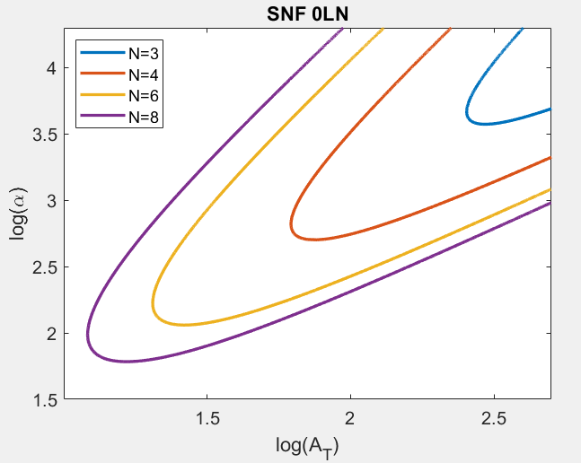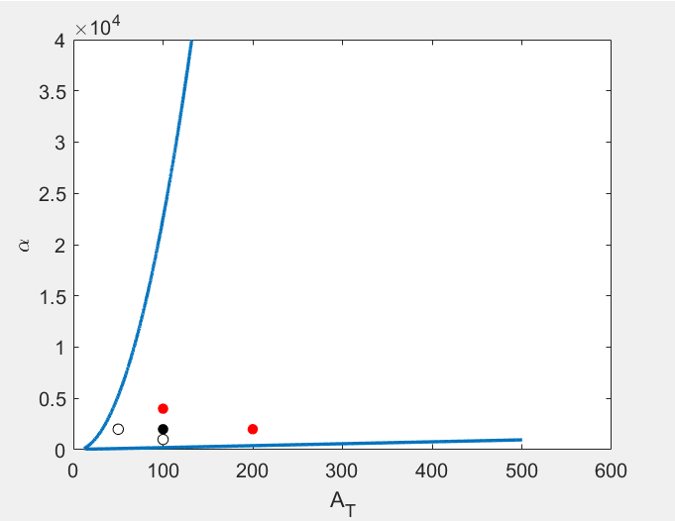

*Black circle* corresponds to the default At-alpha value for homozygous diploid, which is

At=100, alpha=2,000

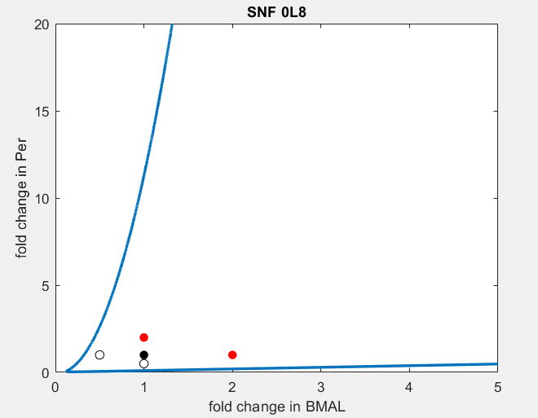

2. NNF 0L8

delta= 0.26, Amax=118, Vmax=1.5

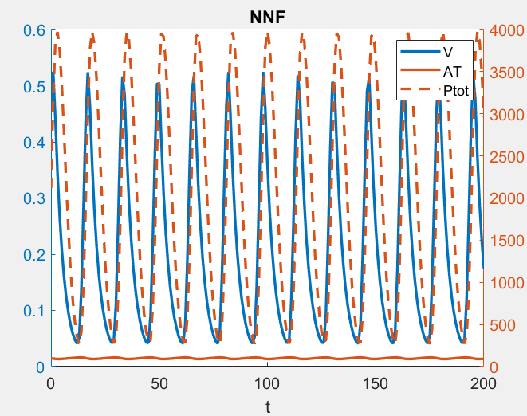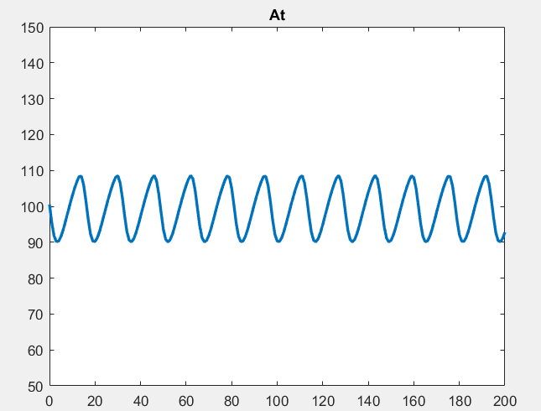

average(At) ~ 100, relative amplitude is ~0.2, period ~16, which are consistent with SNF 0L8.

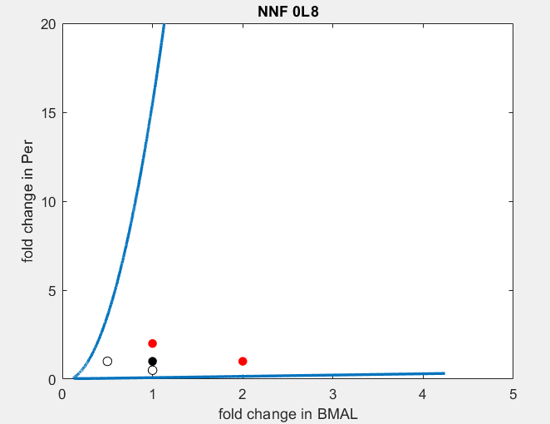

Default Amax=118, alpha=2,000

3. PNF 0L8

delta= 0.12, Amax=228, Rmax=6.3

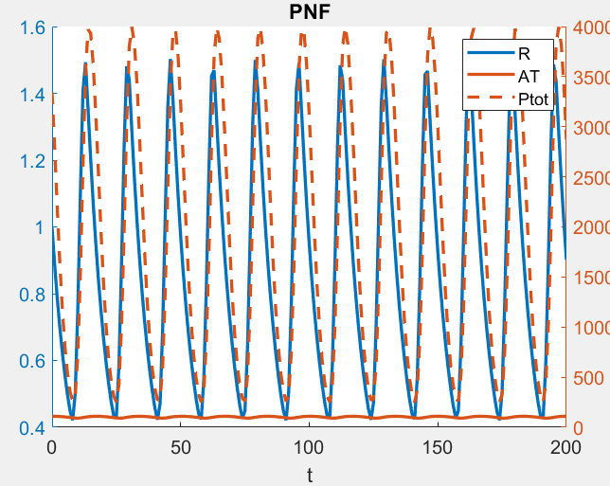 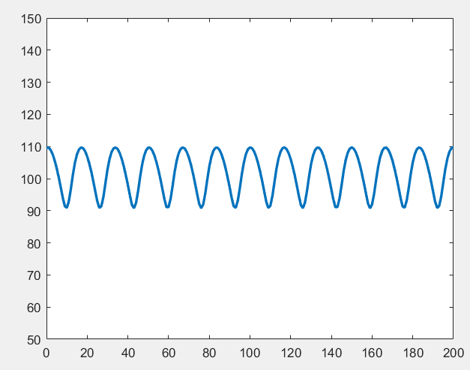

avg(At)~ 100, max(Ptot)~4,000, period(Ptot)~16

Default Amax=228, alpha=2,000

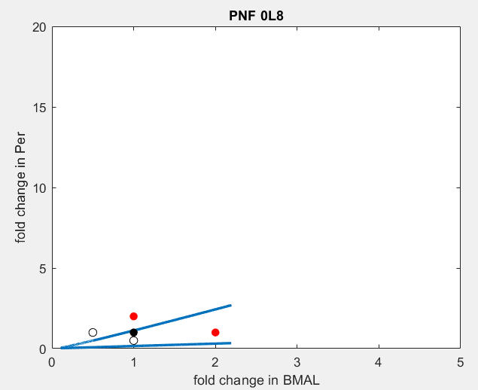

Overlay of SNF, NNF and PNF

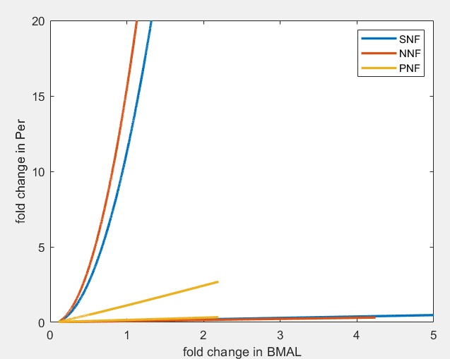

(1,1) corresponds to the default expression of Bmal and Per for different models

SNF 0M8

Km = 1, beta=3.8

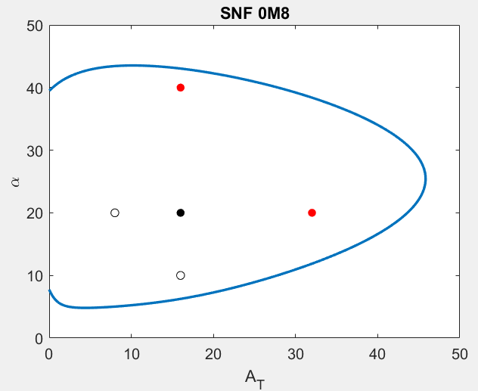 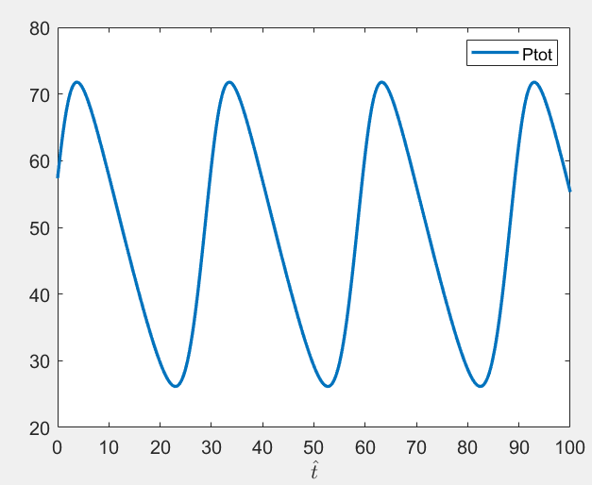

At=16, alpha=20,

max(Ptot)~75, period(Ptot)~30

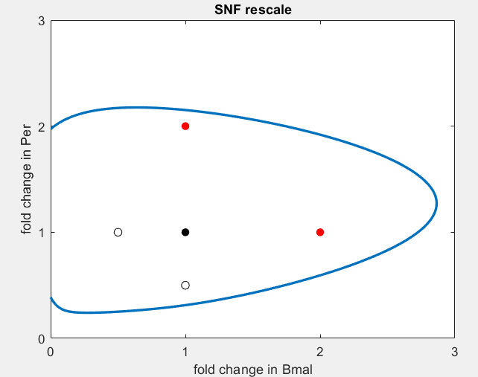

NNF

delta= 0.06, Amax=114, Vmax=38

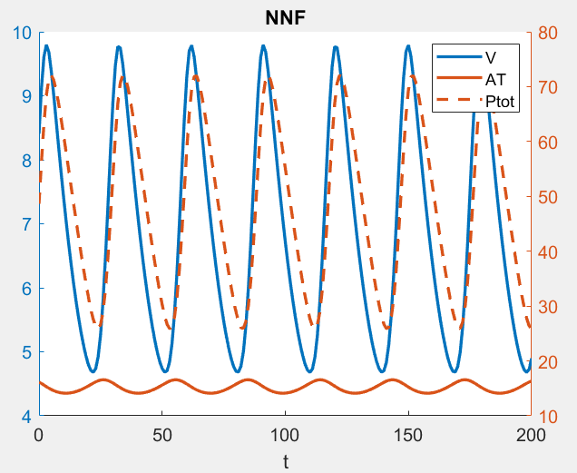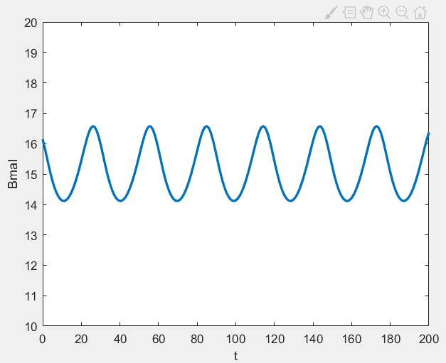

avg(Bmal)~16,

max(Ptot)~75, period(Ptot)~30

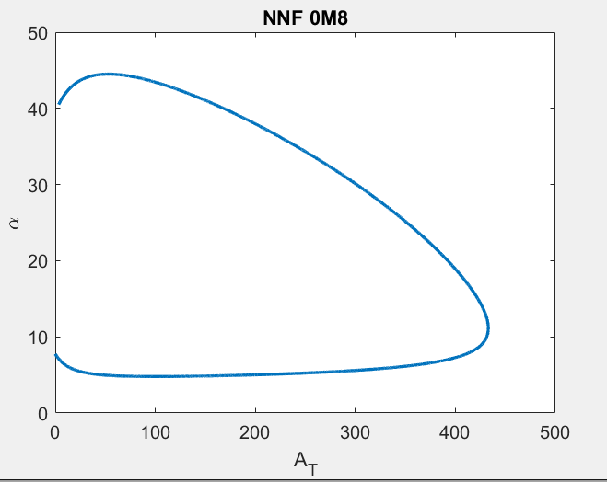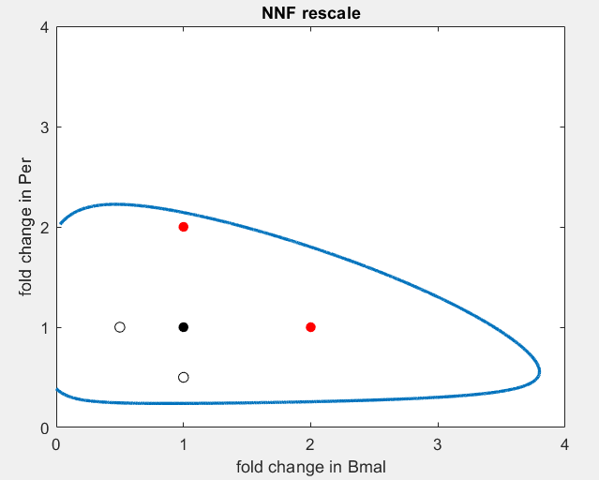

PNF

delta= 0.1, Amax=25, Rmax=11

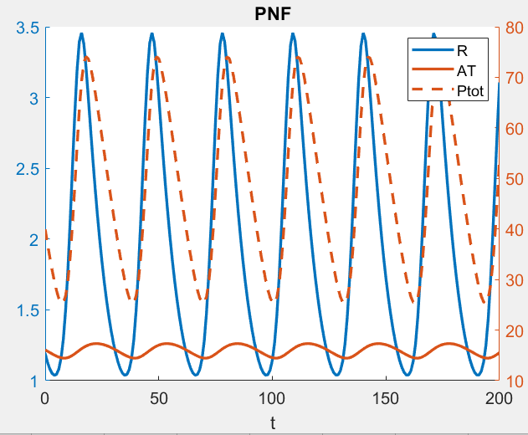

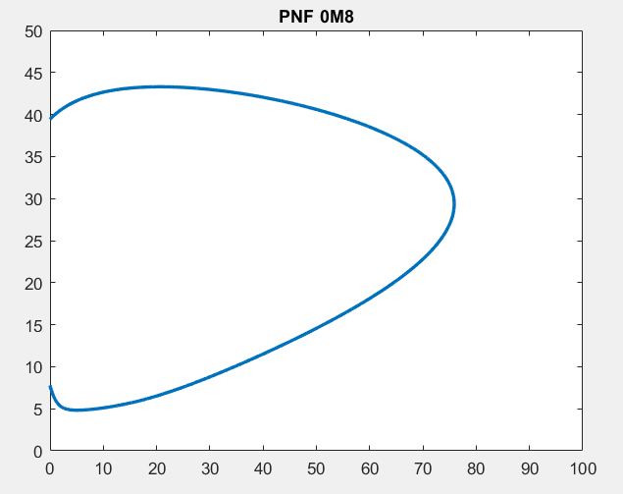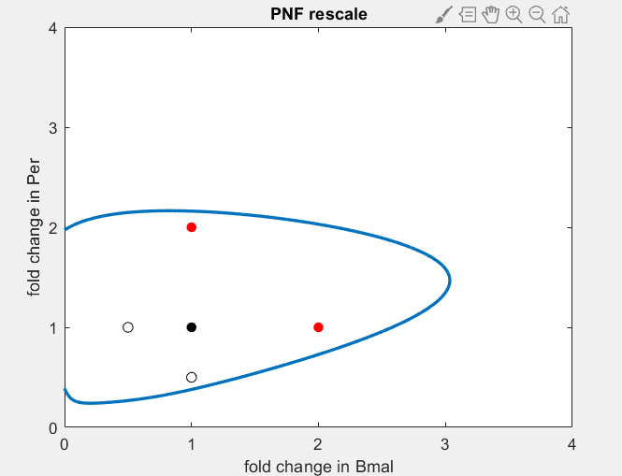

Overlay of fold-change of Bmal-Per unscaled Vs scaled.

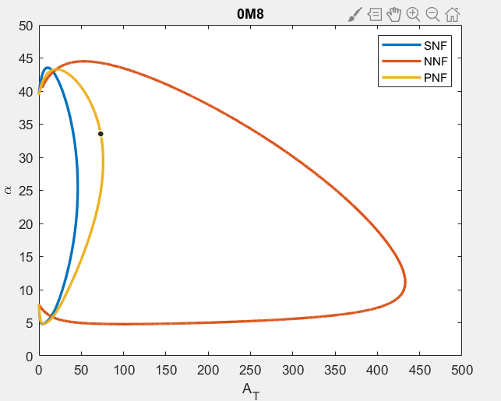

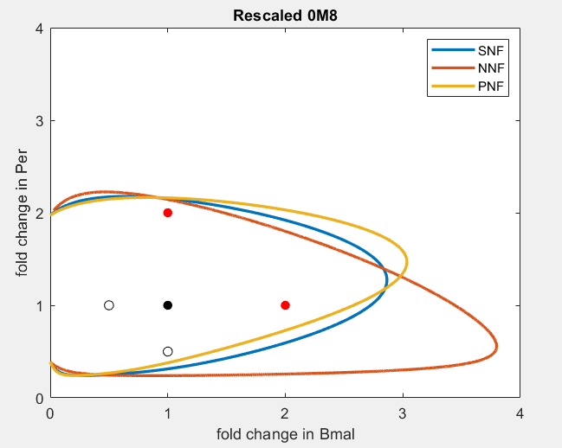

1MN models

1. SNF 1M8

Kd=1, Vmax=5, Km=5.5, KA=20, AT=20, alpha=50

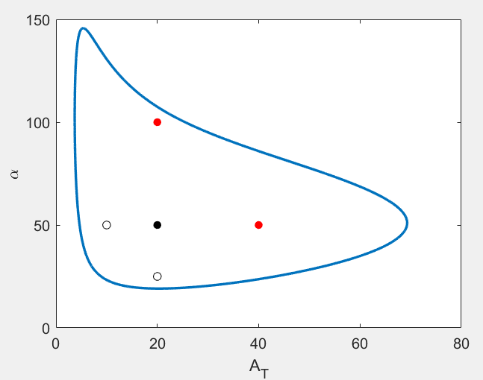 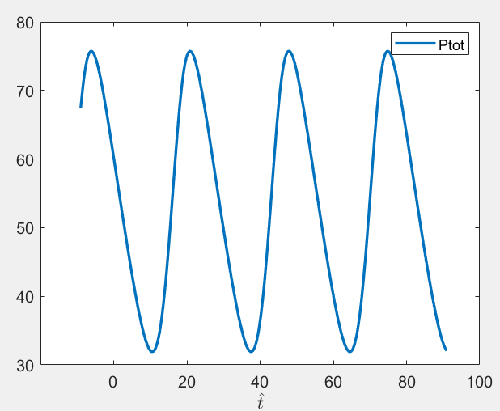

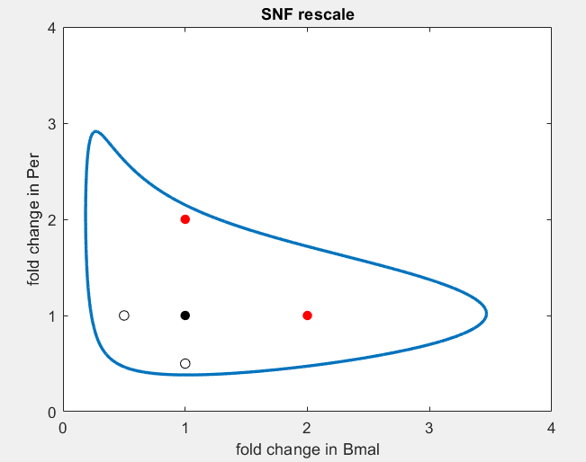

2. NNF 1M8

delta = 0.1, Amax=40, Vmax=13

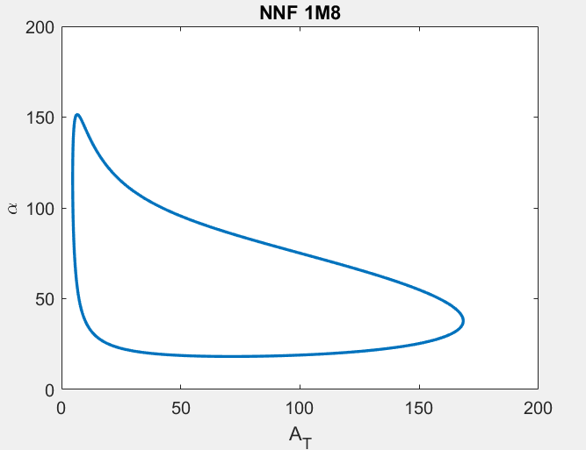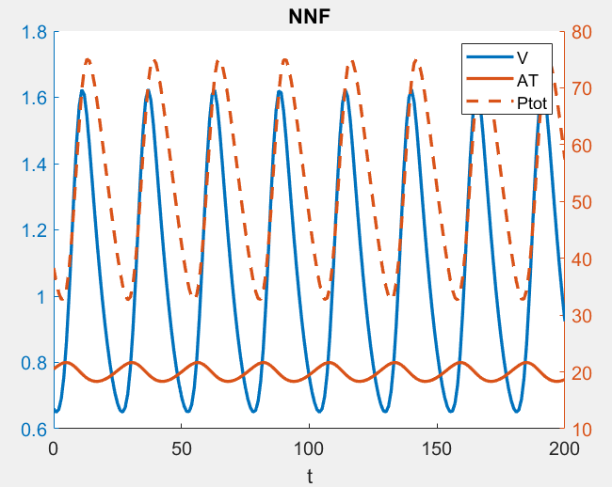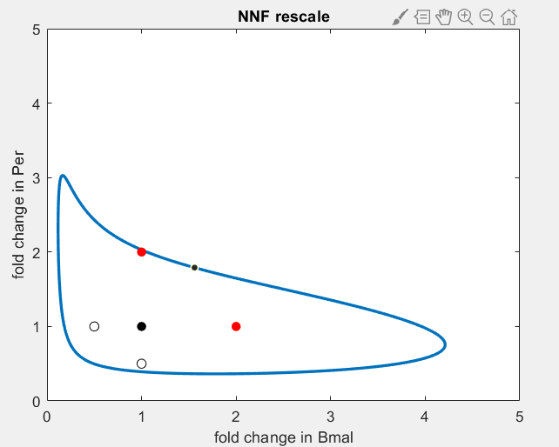

3. PNF 1M8

delta = 0.09, Amax=55.4, Rmax=7.3

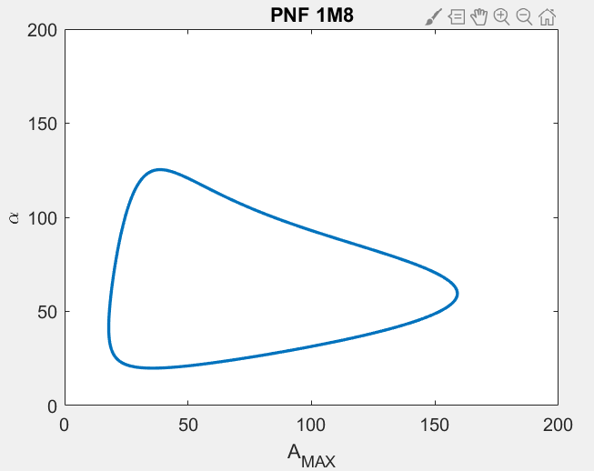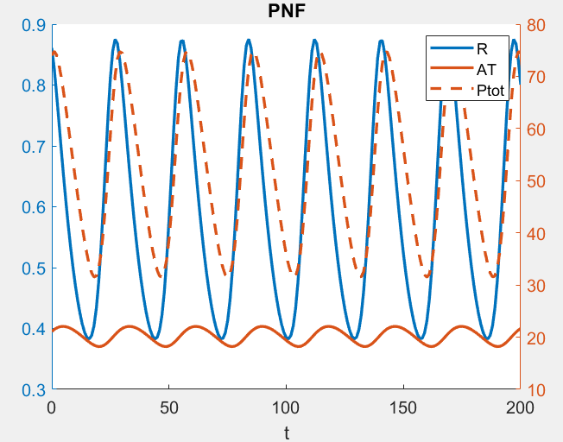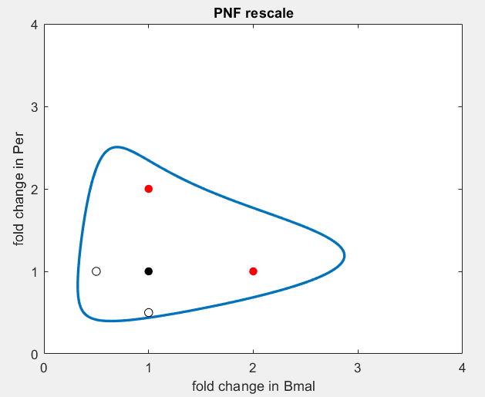

Overlay

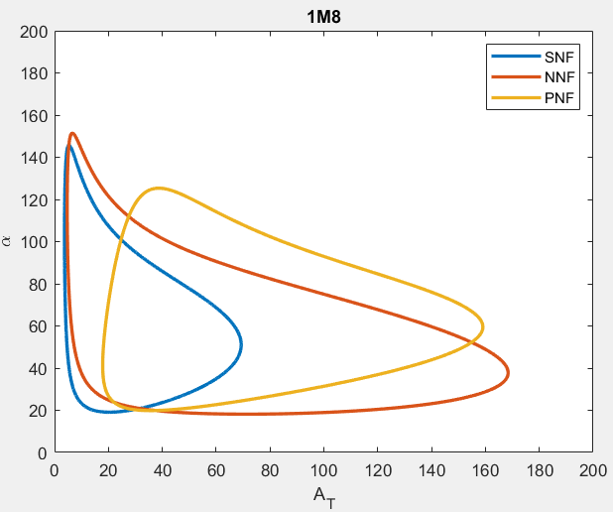

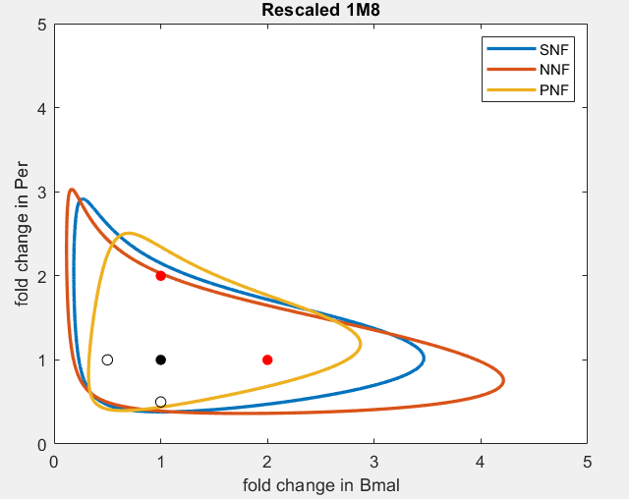

For 1M8, there are old parameter sets that don’t have the period matching constraints.

NNF

= 0.17, Amax=41, Vmax=14

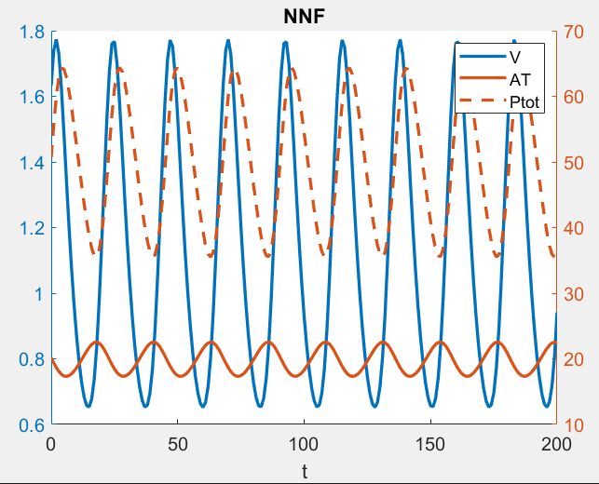

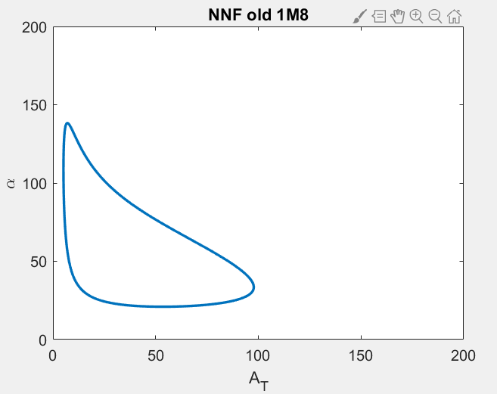

PNF

 = 0.12, Amax=56, Rmax=6.5

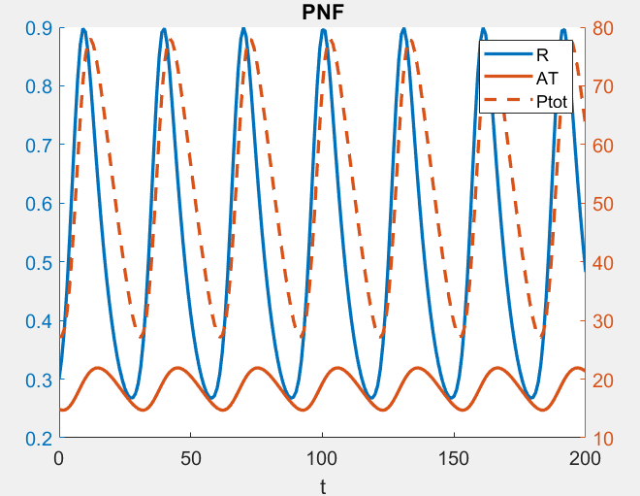

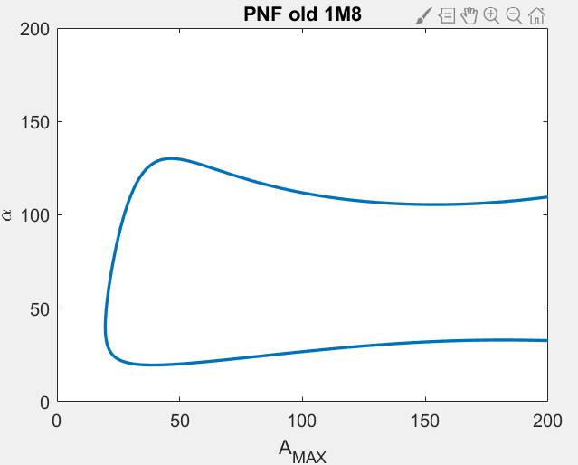

Overlay of Amax-alpha

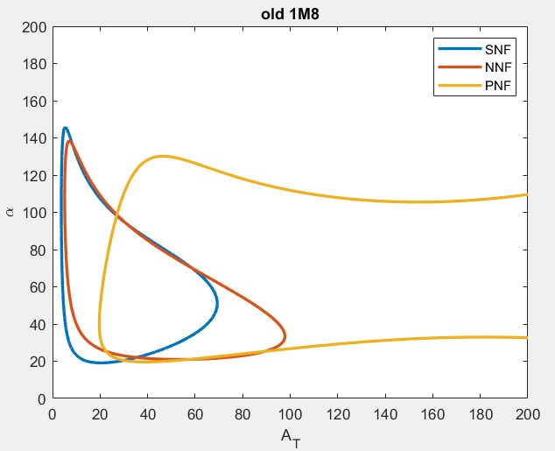

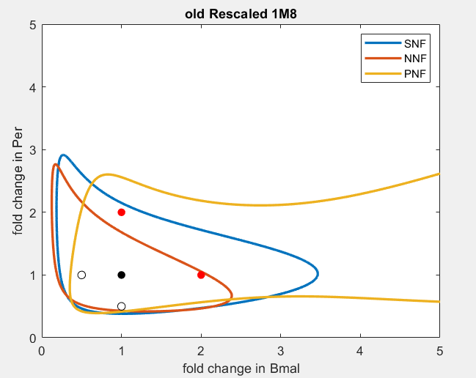

Summary of tested parameter sets

|  |  |  |  |
| --- | --- | --- | --- |
| SNF 1M8 new parameter values searched with constraints  1. Bmal matches SNF, amp ~ 0.2  2. Ptot rhythmicity matches SNF  3. max(Rev)<10, max(Ror)<5 | | | |
|  | SNF | NNF | PNF |
| Kd | 1 | 1 | 1 |
| Vmax (MM) | 5 | 5 | 5 |
| Km | 5.5 | 5.5 | 5.5 |
| Ka | 20 | 20 | 20 |
| At0 | 20 |  |  |
| Alpha | 50 | 50 | 50 |
| Delta |  | 0.1 | 0.09 |
| Amax |  | 40 | 55.4 |
| Vmax |  | 13 |  |
| Rmax |  |  | 7.3 |

|  |  |  |  |
| --- | --- | --- | --- |
| SNF 1M8 oldparameter values searched with constraints  1. Bmal matches SNF, amp ~ 0.2  2. max(Ptot) matches SNF  3. max(Rev)<10, max(Ror)<5 | | | |
|  | SNF | NNF | PNF |
| Kd | 1 | 1 | 1 |
| Vmax (MM) | 5 | 5 | 5 |
| Km | 5.5 | 5.5 | 5.5 |
| Ka | 20 | 20 | 20 |
| At0 | 20 |  |  |
| Alpha | 50 | 50 | 50 |
| Delta |  | 0.17 | 0.12 |
| Amax |  | 41 | 56 |
| Vmax |  | 14 |  |
| Rmax |  |  | 6.5 |